**EARTH & UNIVERSE - REVISION FOR YEAR 10 EXTENSION**

1. Compare the absolute magnitude and apparent magnitude of a star.

______________________________________________________________________________________________________________________________________________________________________________________________________________________________________________________________________________________________________________________________________________________________

1. Which unit will you use to determine the distance between stars? _________________
2. What is a light year (l.y.) and an astronomical unit? ______________________________________________________________________

______________________________________________________________________

1. How far is 34.6 light year in km?

______________________________________________________________________

1. i) Which star will be the brightest? Betelgeuse with an absolute magnitude of -5.14 or Bellatrix with an absolute magnitude of -2.72? _____________________________

ii) The planet Venus has an apparent magnitude of -4.7 and Jupiter has an apparent magnitude of -2.9. Which is brighter, justify your answer.

___________________________________________________________________

___________________________________________________________________

1. Stars emit light at a range of different wavelengths of the electromagnetic spectrum.

Which star will be the hottest, a star emitting mainly blue light or a star emitting mainly red light? _____________________________________________________________

1. By using a spectrometer to split light into a spectrum, a scientist can gather two very important bits of information about a star. Name the information that the colour of stars can reveal to scientist.

__________________________________________________________________________________________________________________________________________________________________________________________________________________

1. What is the spectral class of a star? _________________________________________

______________________________________________________________________

1. The table below shows spectral classes of stars with their associated temperature and colour.

[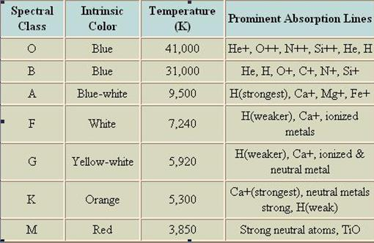](https://www.google.com.au/url?sa=i&rct=j&q=&esrc=s&frm=1&source=images&cd=&cad=rja&docid=9iB-h1VYvd1hIM&tbnid=yWbcKx_VWD9TpM:&ved=0CAUQjRw&url=https://sjhsrc.wikispaces.com/CN%2BMilestone%2BMap%2B-%2BSpectral%2BClasses&ei=o8t5UoaRDMuUkgXGqIGQBg&bvm=bv.55980276,d.dGI&psig=AFQjCNFq-DnJkTAFzBkJzYucd5UEAVODOw&ust=1383800081664222)

* 1. If a star has a temperature of 9750oC what colour will it be? _______________
  2. Is a star in a spectral class O brighter than one in G. Explain why you think this is so? (Hint: think about temperature and energy)

_____________________________________________________________________

_____________________________________________________________________

* 1. Our sun has a surface temperature of just below 6000o C, what is its intrinsic colour and to which spectral class does it belong? ________________________

________________________________________________________________

1. Explain how the light inside a star is produced. _______________________________

______________________________________________________________________

1. Astronomers have studied the brightness and colour of stars and graphed them on a diagram called a Hertzsprung–Russell diagram. You can see one below. Use this diagram to answer the questions below. Luminosity refers to the absolute magnitude of a star.

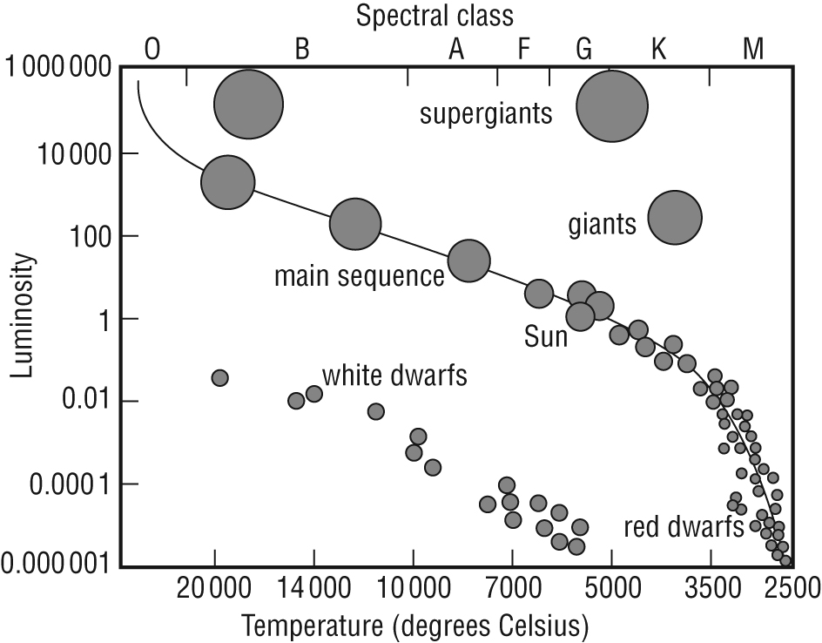

1. To what spectral class does the Sun belong? __________________________________
2. What does it mean if a star is in the “main sequence?
3. Name the forces that are in balance if a star is in the “main sequence”

__________________________________________________________________

__________________________________________________________________

1. Explain, using diagrams, the life cycle of a medium sized star.
2. Explain, using diagrams, the life cycle of a large sized star.
3. Relationship for main sequence stars state: The heavier the mass the brighter and hotter they will be. Why is this so?

______________________________________________________________________

__________________________________________________________________________________________________________________________________________________________________________________________________________________

1. Do you think stars that are more massive burn up fuel more quickly or slowly?

______________________________________________________________________

1. a. What is the difference between a neutron star and a black hole?

1. Other than the colour, what is the difference between a white and black dwarf?

_________________________________________________________________________________________________________________________________________________________________________________________________________________

1. a. Explain the formation of black holes. ______________________________________

__________________________________________________________________________________________________________________________________________________________________________________________________________________

b. If light isn’t able to escape a black hole. How do we detect for the presence of them?

________________________________________________________________________________________________________________________________________________________________________________________________________________________________________________________________________________________

1. Explain how the red-shift, similar to a phenomenon known as the Doppler effect is used to provide evidence for the “Big Bang” theory.

____________________________________________________________________________________________________________________________________________________________________________________________________________________________________________________________________________________________________________________________________________________________________________________________________________________________________

1. What is cosmic background radiation?

____________________________________________________________________________________________________________________________________________________________________________________________________________________________________________________________________________________________________________________________________________________________________________________________________________________________________

1. With the aid of a diagram, explain how carbon is cycled through the biotic and abiotic components of terrestrial and aquatic ecosystems.
2. Explain the causes and effects of anthropogenic climate change on Earth’s ecology. Refer to the impacts of climate change on coral bleaching and melting ice.